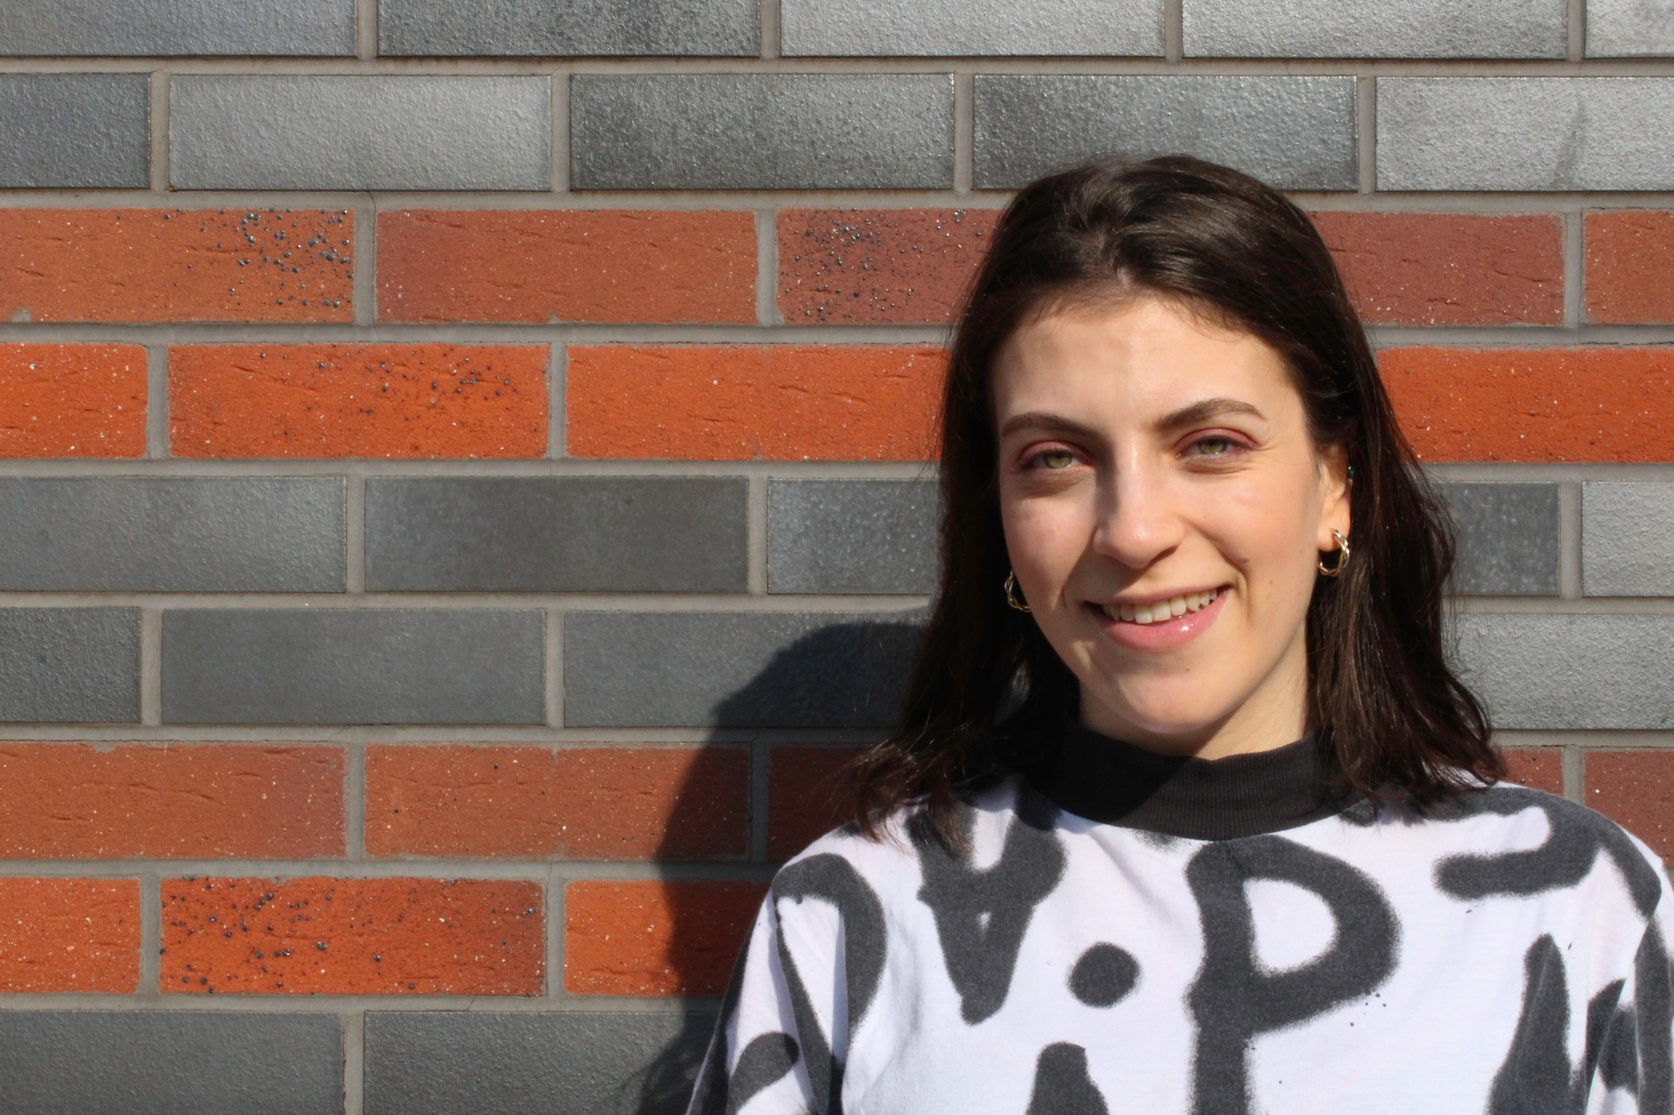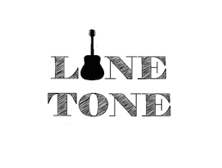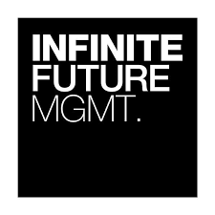**

***Presenter for ScratchTV (August 2018 - present)***

* A presenter for Birmingham City University’s channel ScratchTV.
* Interviewing artists and music industry professionals.

***Setting up a Record Label - Lone Tone Records (September 2015- August 2017)***

* Co-found a record label
* Created and managed the online presence, including a website and social media platforms.
* Organised our first gig at a popular music venue with a 300+ people turnout.

**Profile**

***Student Mentor at Birmingham City University (July 2018 – present)***

* Monitor social media platforms and any posts from students.
* Assisting at student events.

***ITV Midlands Work Experience Programme (3 days in April 2018)***

* Shadowed different roles in the studio departments.
* Used Interplay, Avid, Traffic equipment, Prompt, a switcher/ Logic sound board and LiveU.

***Freelance Artist Manager (September 2017- March 2018)***

* Advised artists on social media tactics and campaign planning.
* Produced and edited videos
* Managed camera crews at live music events.

***Temp Admin Assistant at Kobalt Music Group (September 2017- October 2017)***

* Assigned royalties collected by various global societies to the artists and songwriters.

***Intern at Infinite Future Management (June 2017- August 2017)***

* Created content for the artists’ social media platforms on the roster.
* Attended, and minuted meetings with music publishers, labels and agencies.

***Artist Manager Assistant at Hale Artists (May 2017- July 2017)***

* Created visual and written content for the artists’ social media platforms including YouTube, Instagram, Facebook and Sound Cloud.
* Liaised with student radio stations, press and live agents.
* Added tour dates to ticket sites
* Created artists’ one sheets, itineraries and coordinated travel.

**Relevant Media Experience**

***Birmingham City University (2015-)***

Studying for BA Undergraduate in Media and Communications (Music Industries specialist).

Modules taken include: Popular Music Culture, Music Business, Music PR, TV Studio, Media Law, Comedy Theory and Media Innovation.

***JFS (2012-2014)***

3 A-Levels in Media, English Literature and Psychology.

**Extra Projects and Interests**

Overview | Related Artists | About | Concerts

I’m excited by the music industry’s fast pace environment and ever-changing landscape., it allows my creativity to stand out and I’m often the one who brings new ideas to the table. My goal is to pursue a career in music marketing.

At the moment, I’m coding a website that aims to educate young adults about the different aspects of the music industries, with filmed interviews and podcasts with industry professionals. I’m also writing a dissertation on representations of women and feminism in grime music videos.

I’m always looking to make new connections and refine my skills. I’m excited for my future career in the music business where I hope to work with lots of interesting, talented people.

**References are available on request.**

**Education**

* ***Social Media:*** Setting up fan, artist and business pages across the main social media platforms.
* ***Web Design***: HTML (advanced), CSS (advanced) and JavaScript (basic). Advanced in Wix and WordPress. I coded my personal website (see top right for link).
* ***Using music distribution sites:*** SoundCloud, Bandcamp.
* ***Photo and Video editing***: Adobe Photoshop, Premiere Pro, Avid.
* ***Admin***: diary management, calendar coordination, good telephone and email manner.
* ***Writing music:*** Sibelius.
* Sound engineering (basic).
* ***Languages:*** English (fluent), Hebrew (fluent), French (basic).
* Driving license.

**Key Skills**



+44(0)7947746503

[eliana@medalie.co.uk](mailto:eliana@medalie.co.uk)

<http://elianamedalie.co.uk/>

https://www.linkedin.com/in/eliana-medalie-98361b10b/